**TEST REPORTS FOR BILLING AND PREMIUM PAYMENT PORTAL**

**TEST CASES USING JUNIT:**

TEST CASES FOR LOGIN MICROSERVICE:

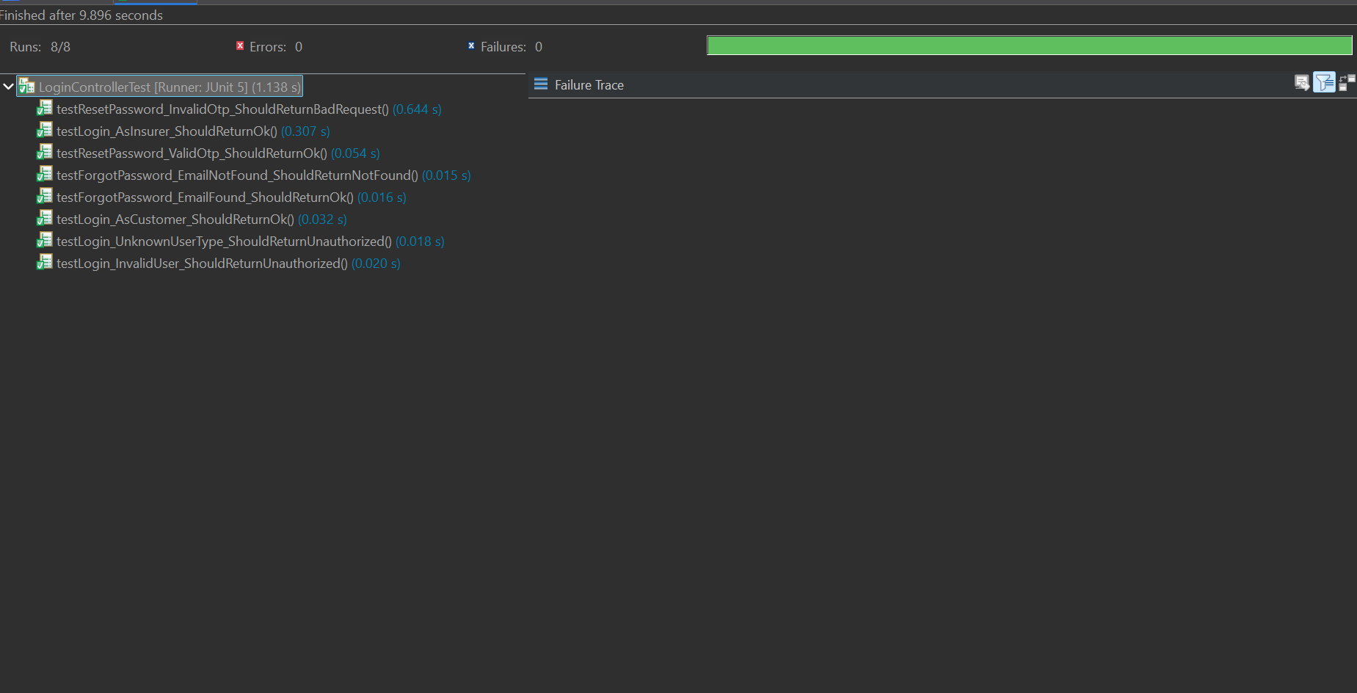

TEST CASES FOR CUSTOMER MICROSERVICE:

Customer Controller:  
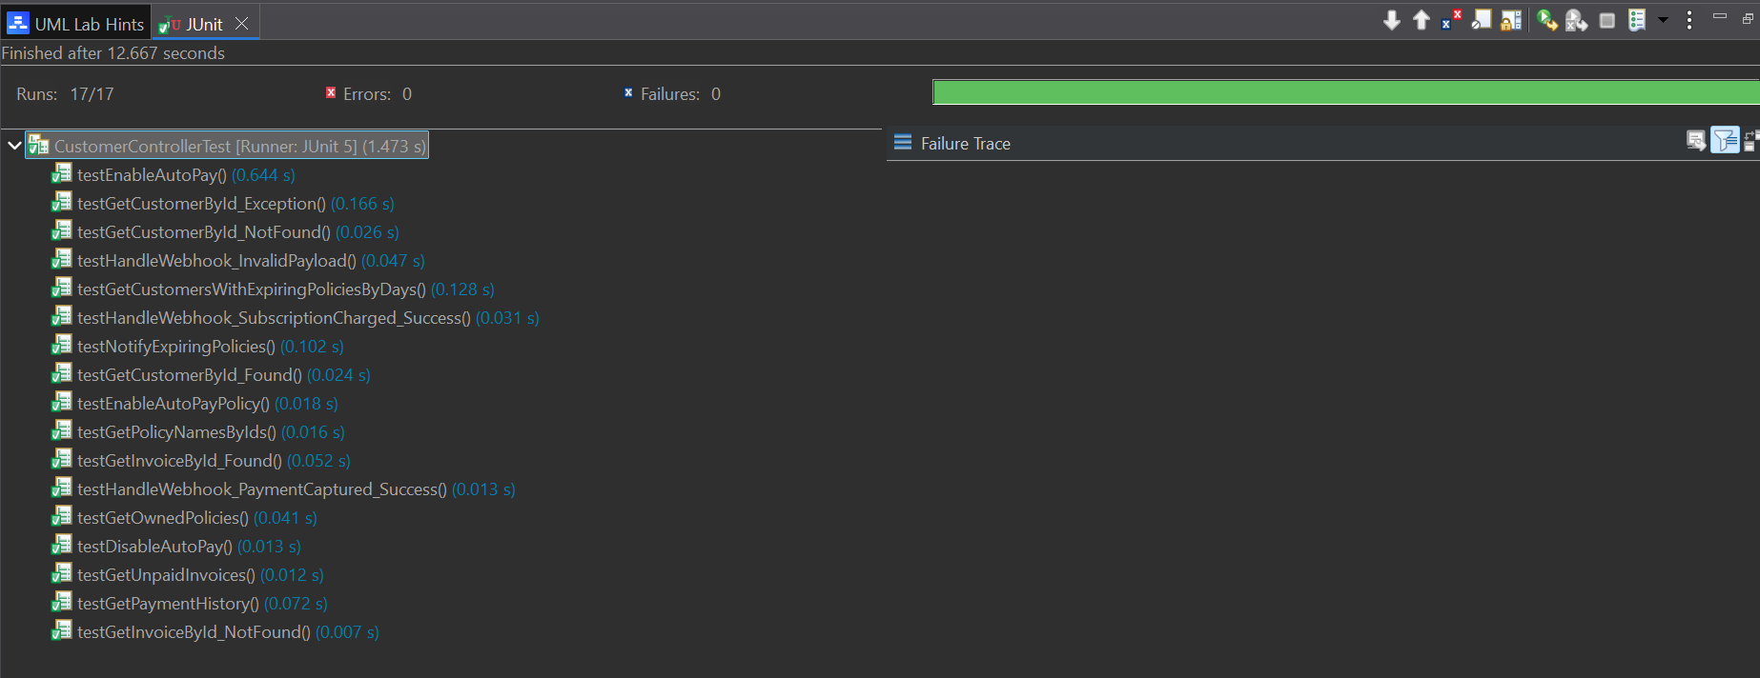

TEST CASES FOR NOTIFICATION MICROSERVICE:

Notification Controller:  
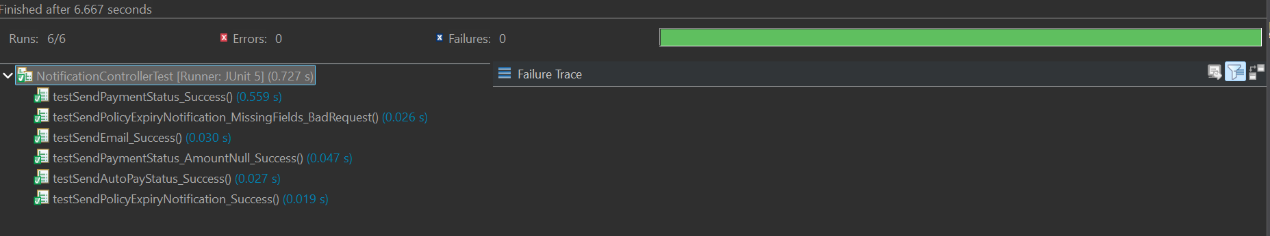

TEST CASES FOR INSURER MICROSERVICE:

Insurer Controller:

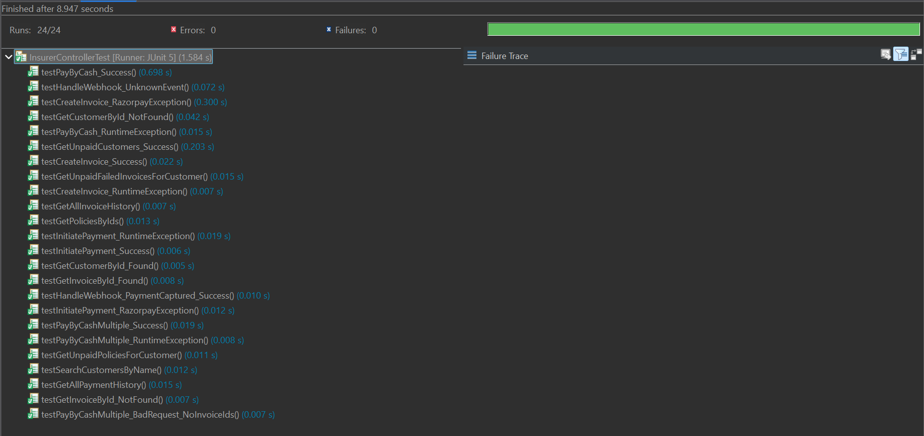

SWAGGER TEST:

LOGIN MICROSERVICE:

LoginController:

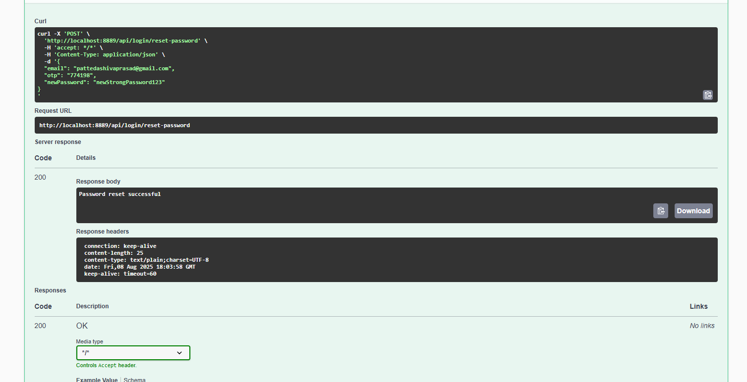

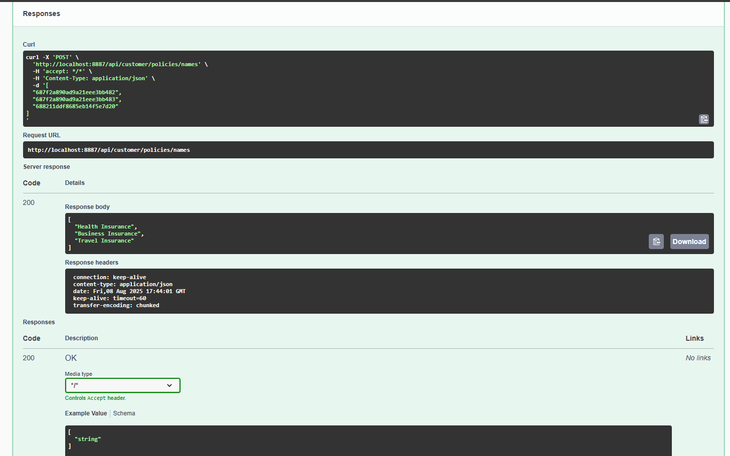



------------------------------------------------

CUSTOMER MICROSERVICE:

CustomerController :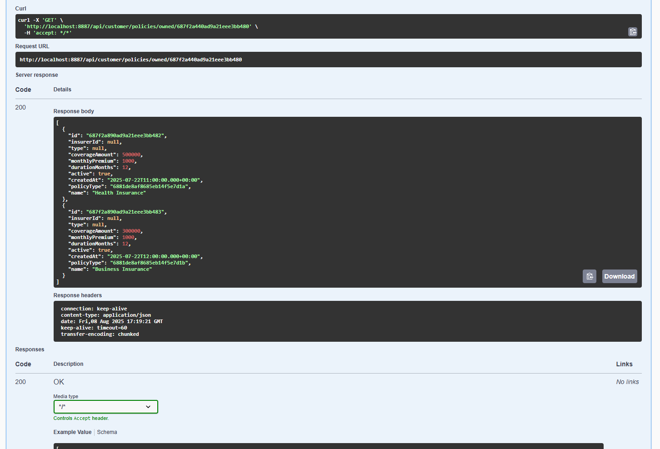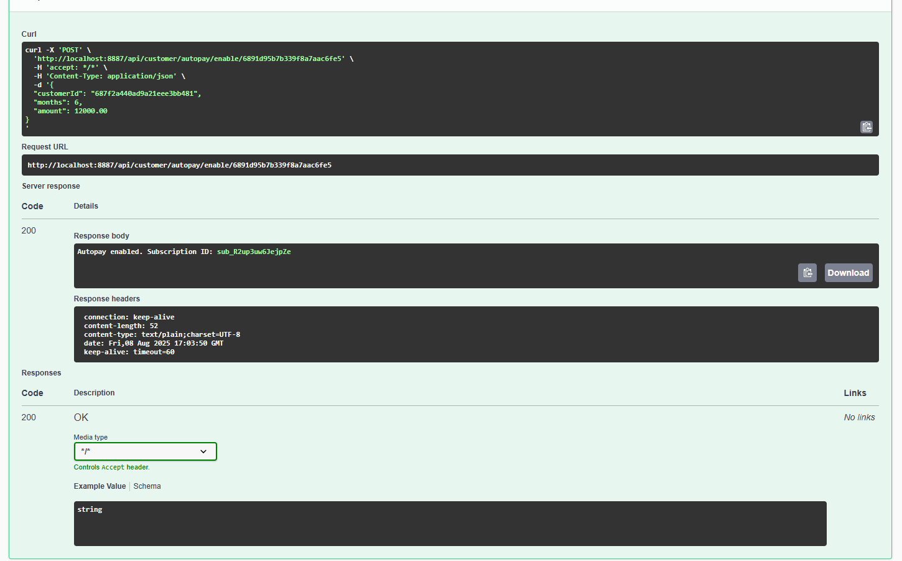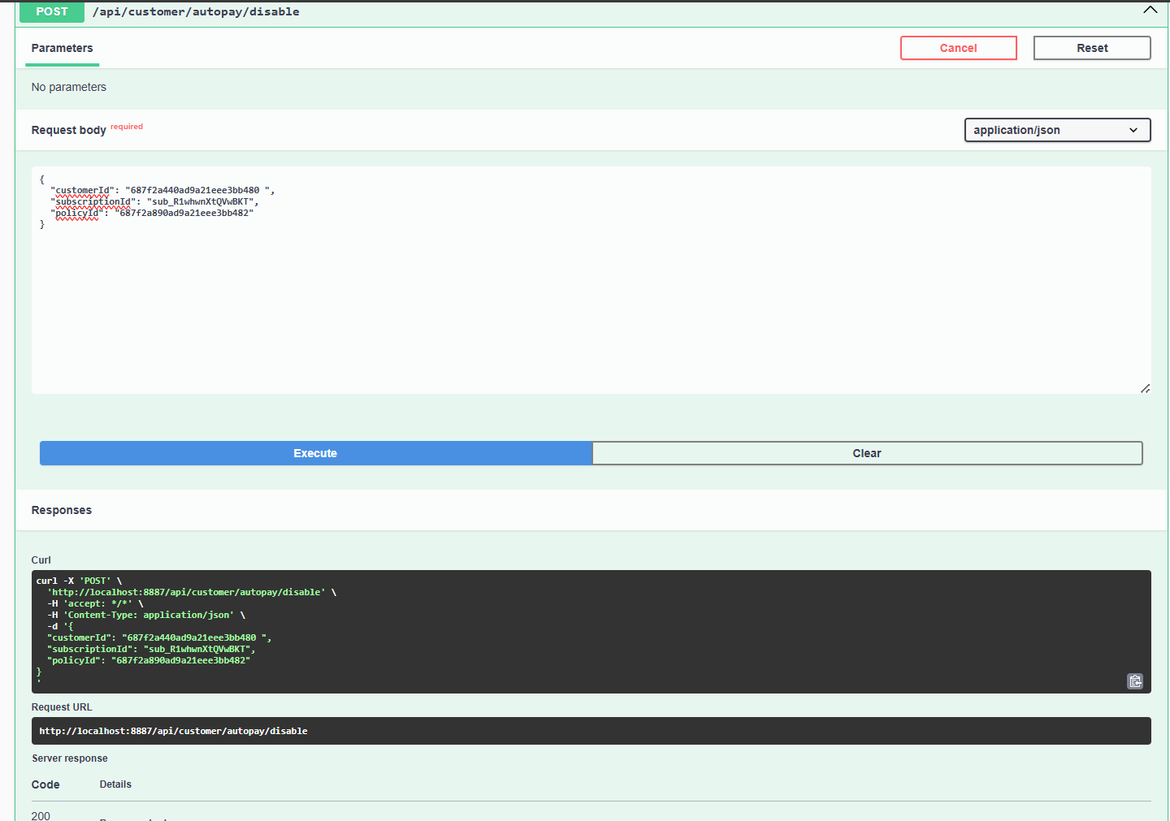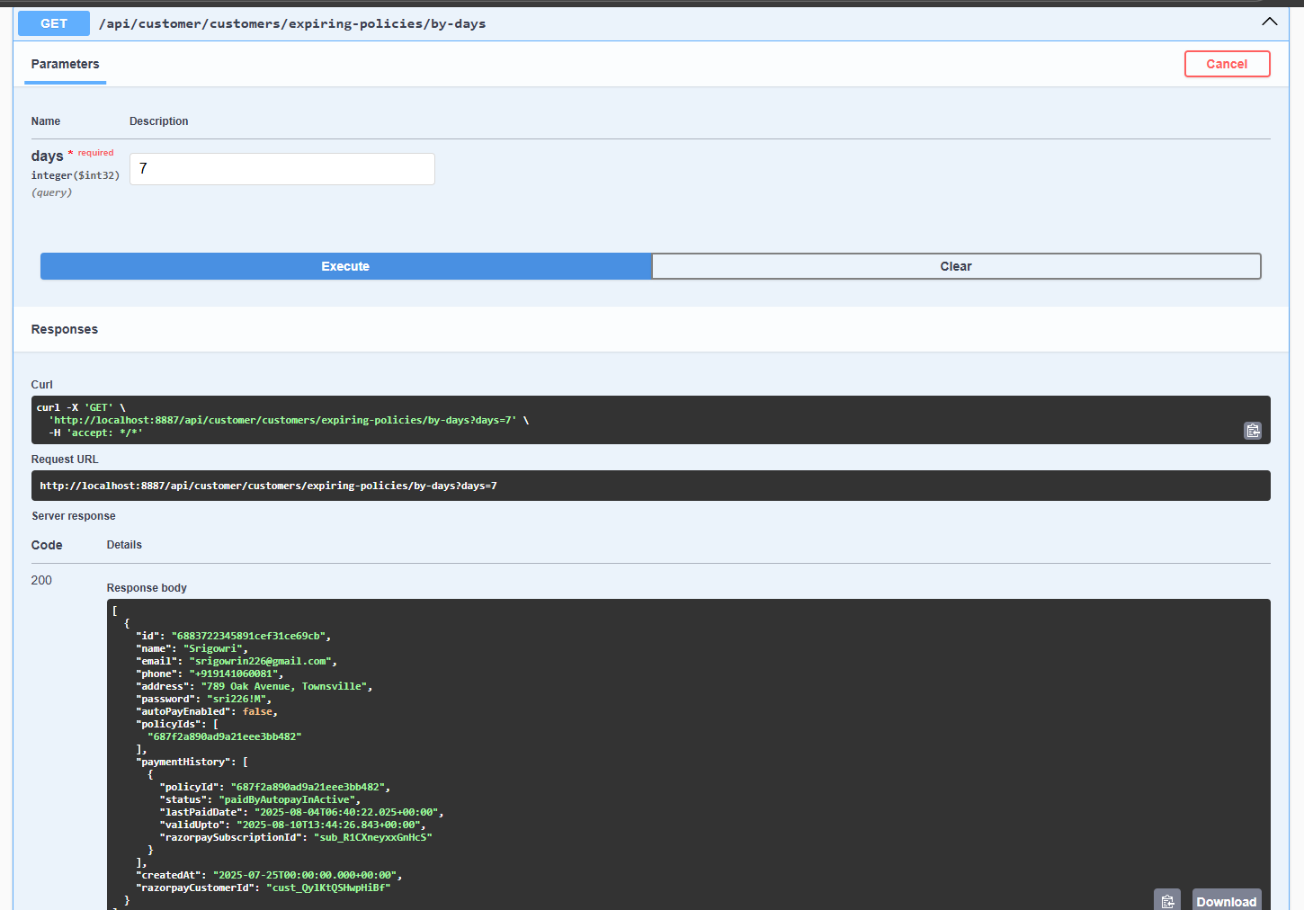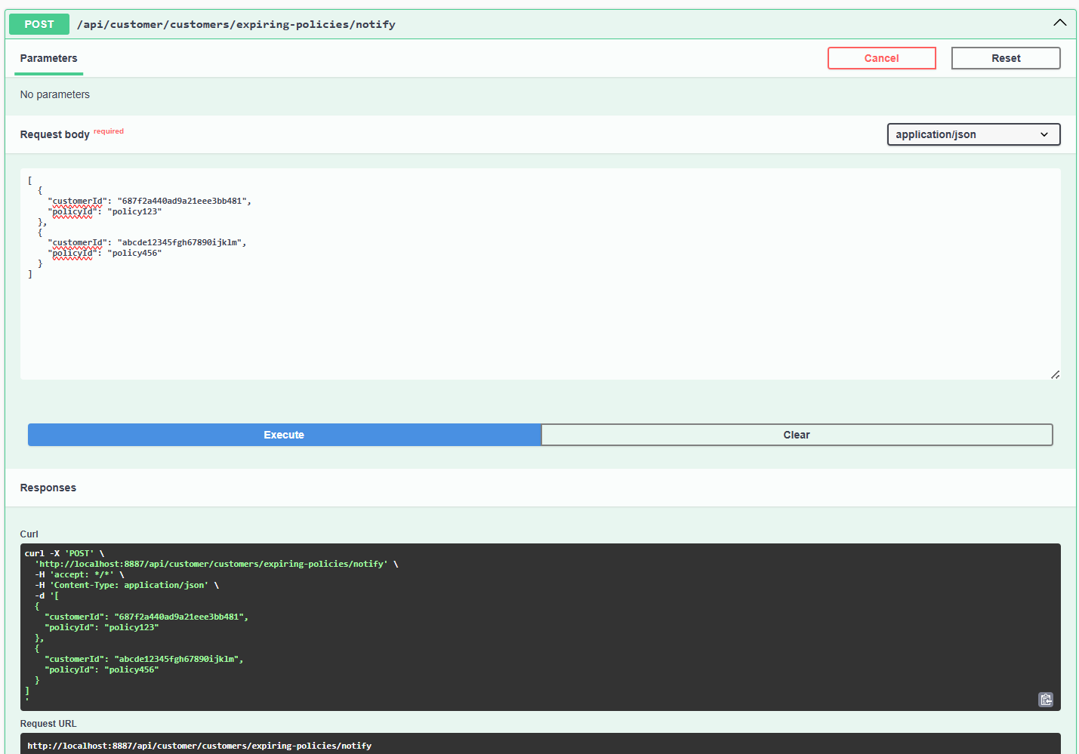

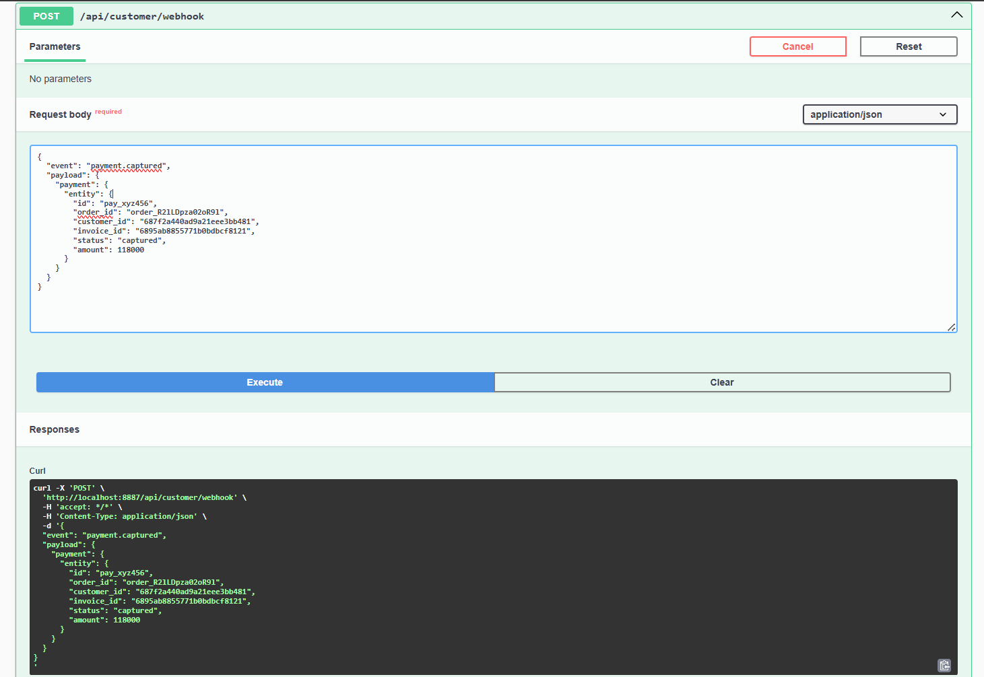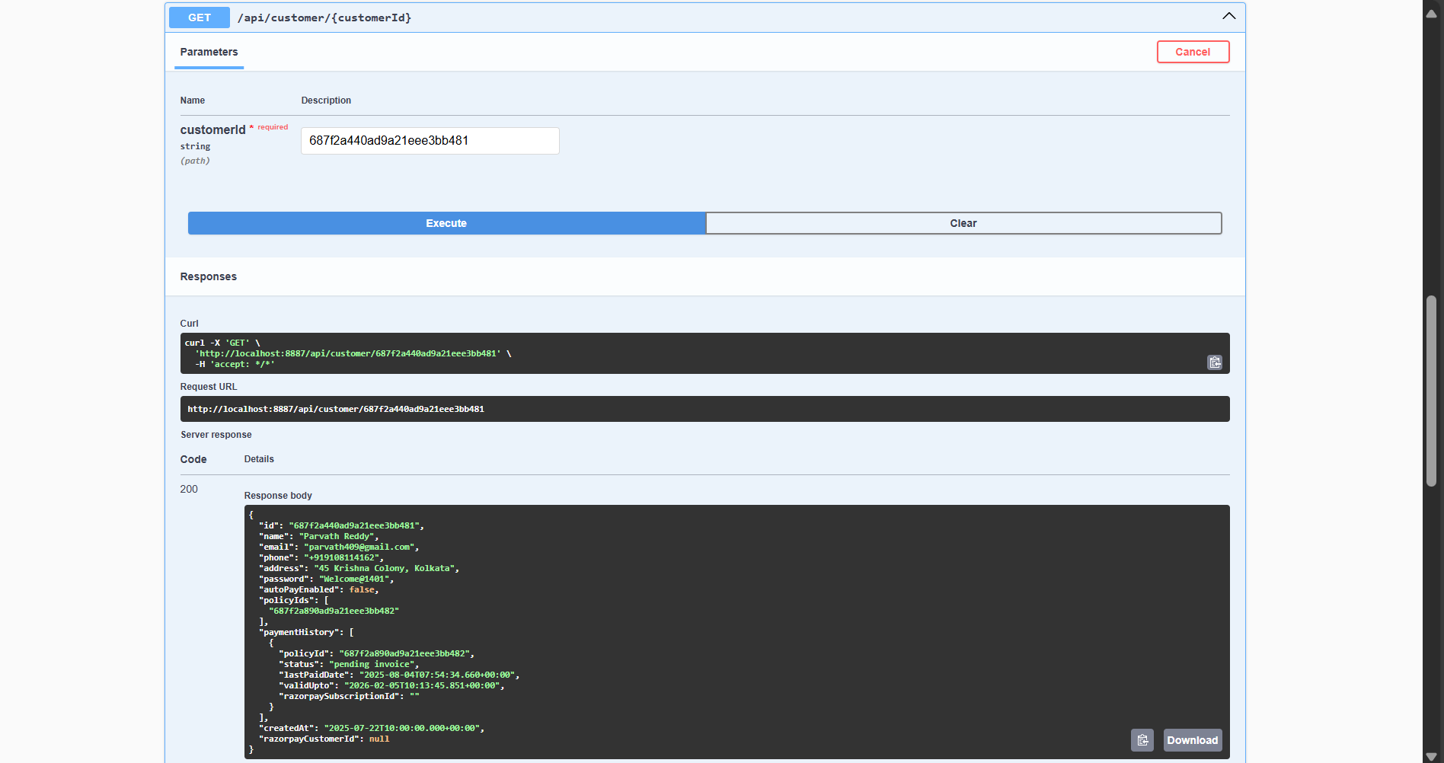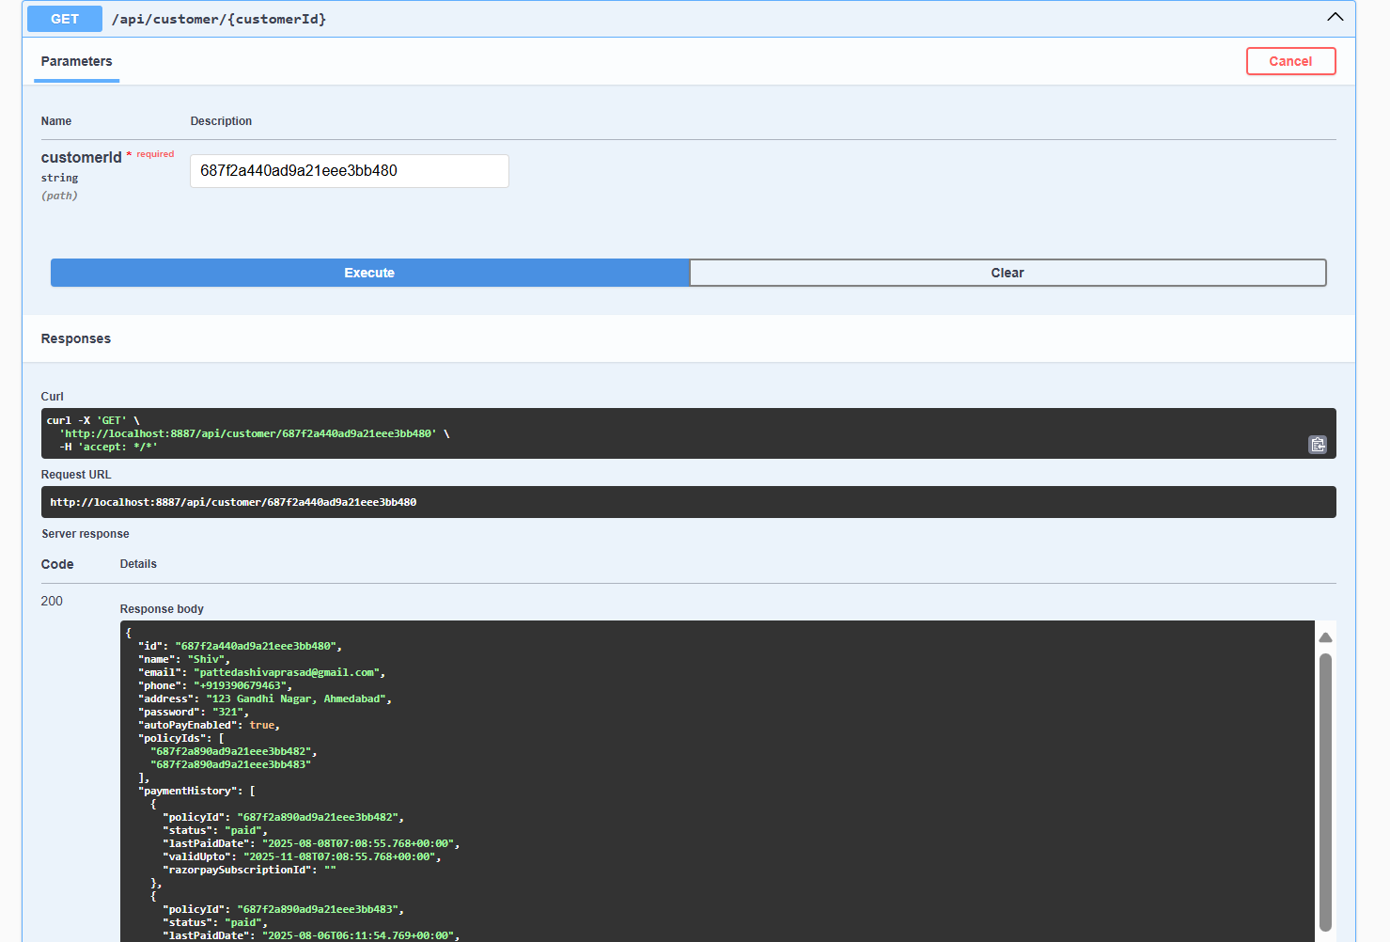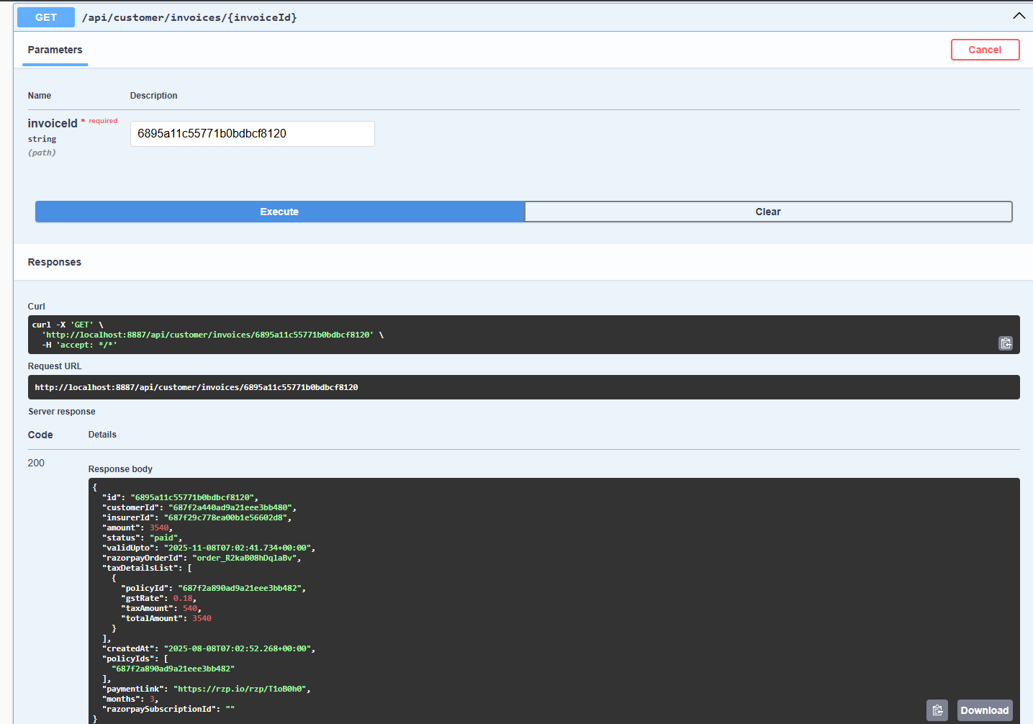------------------------------------------------------

INSURER MICROSERVICE:

InsurerController:

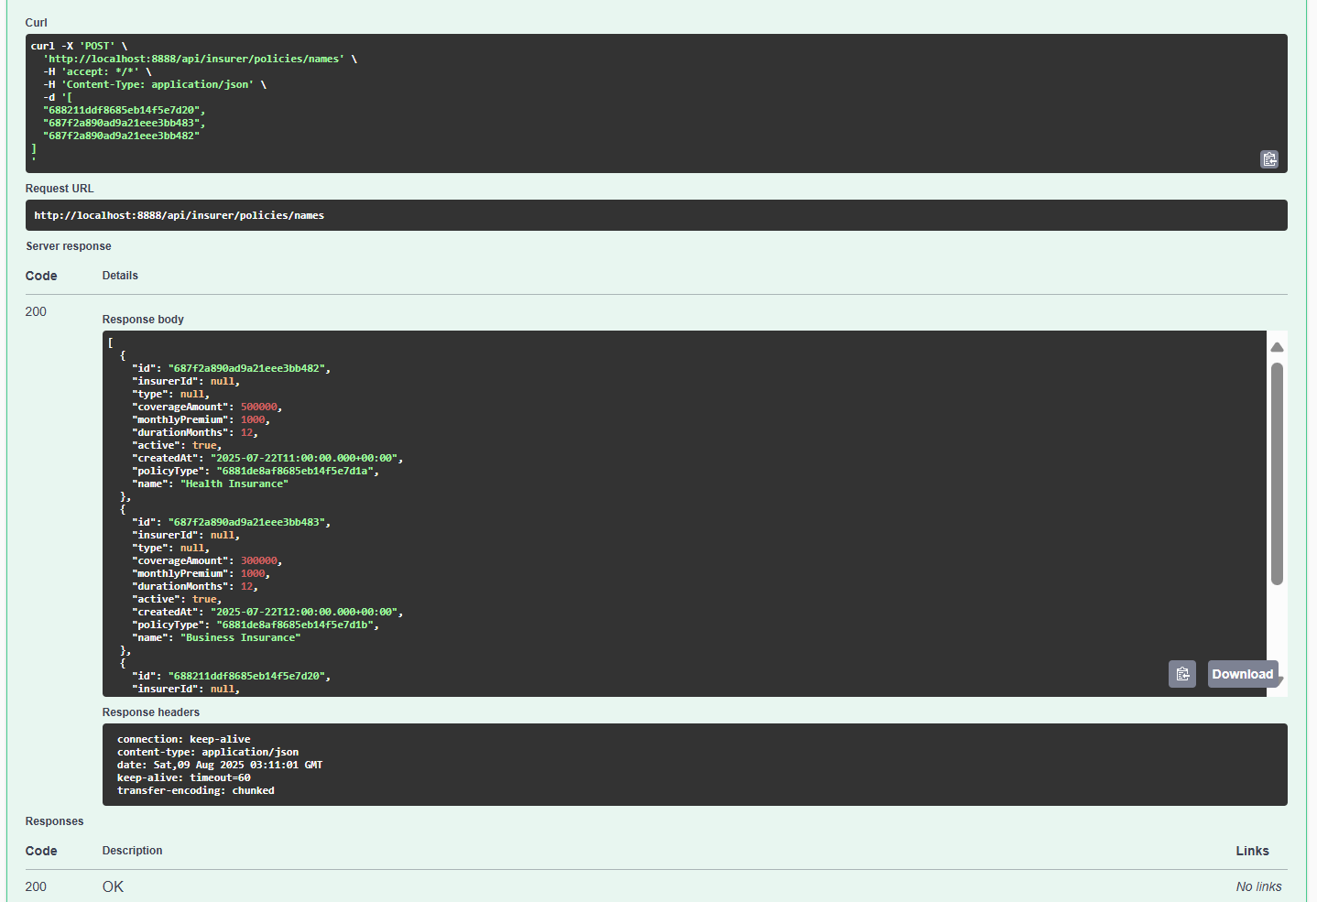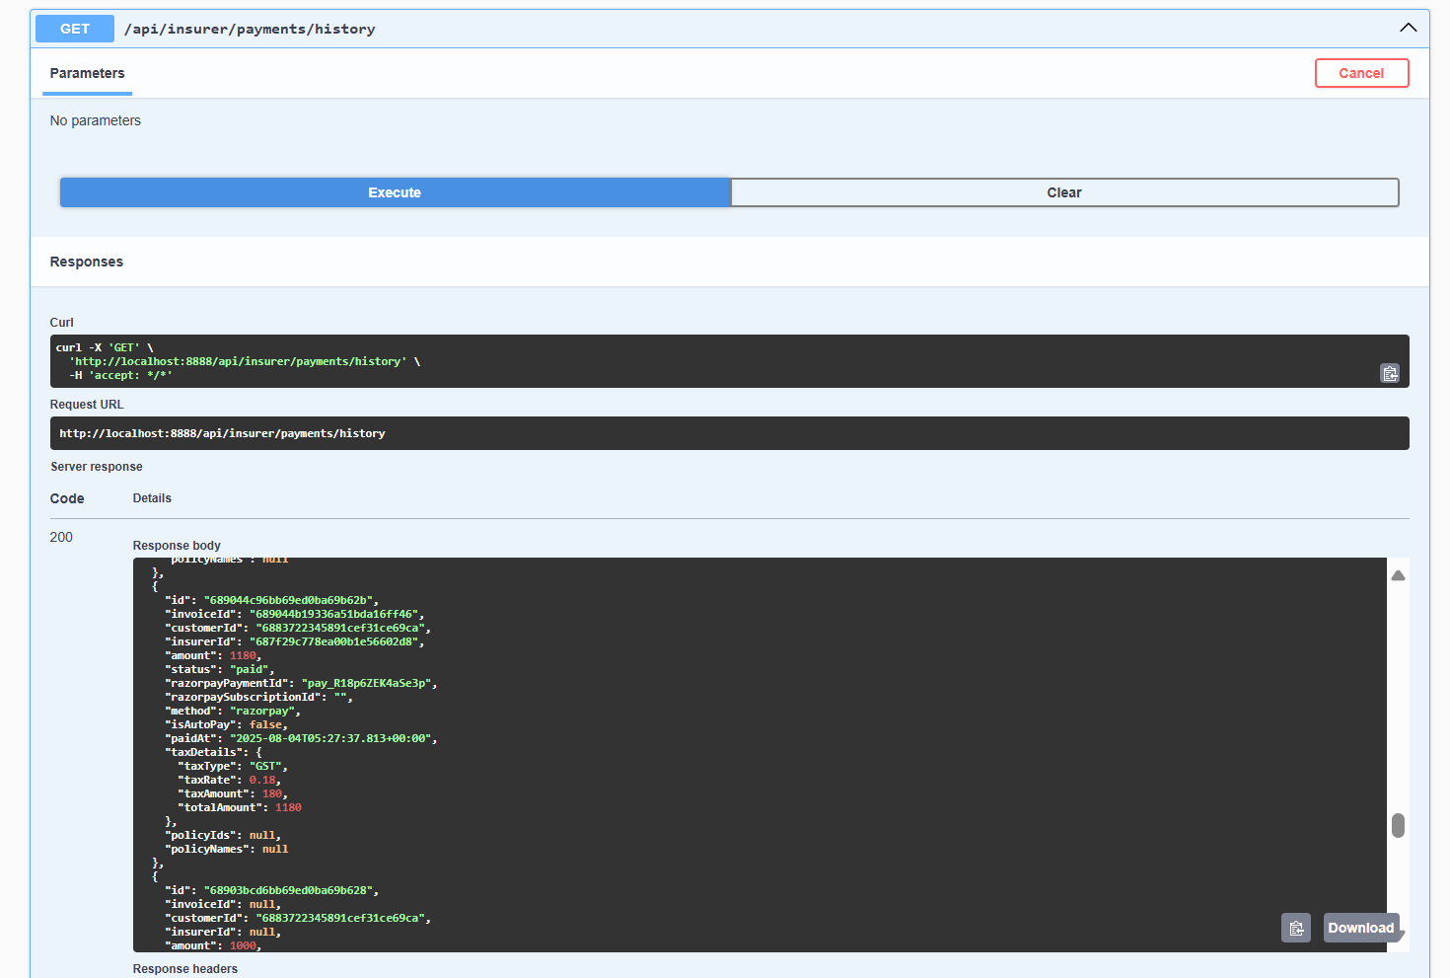

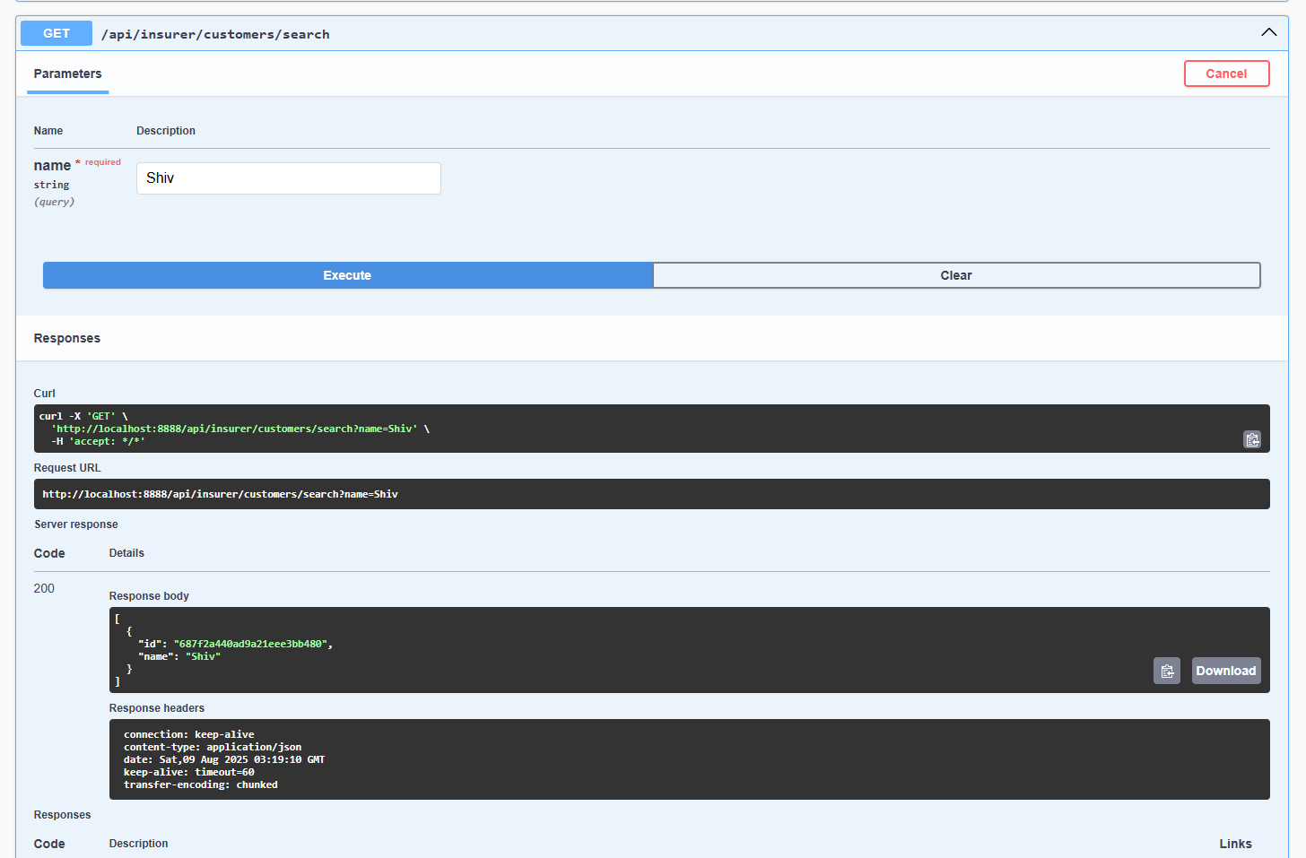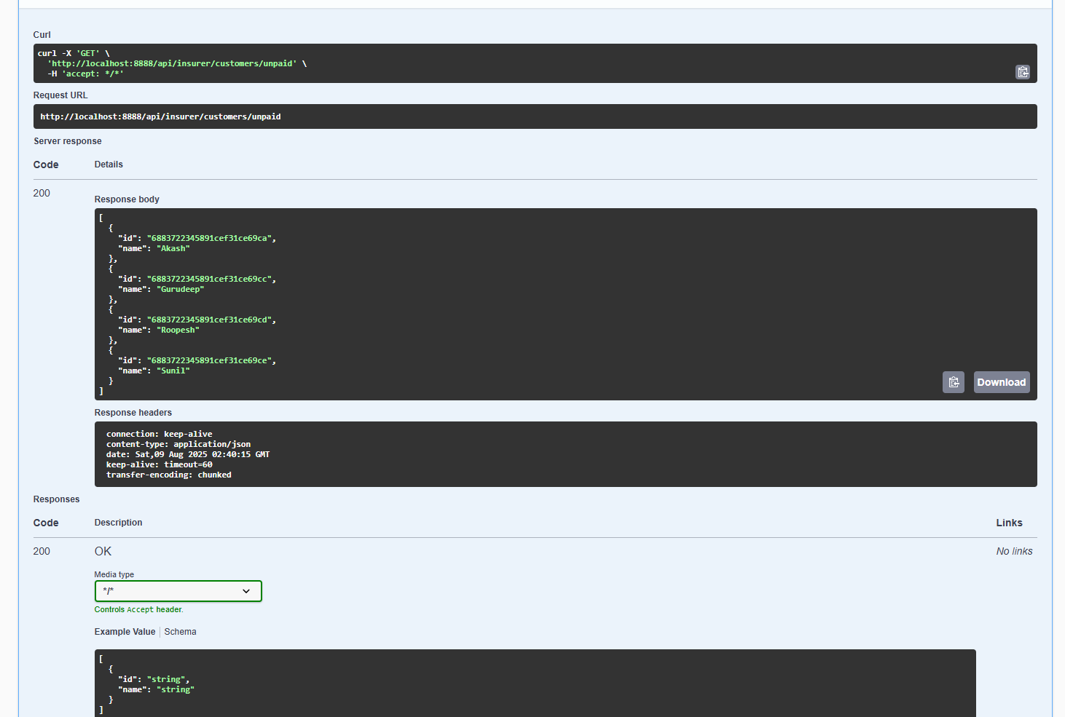

------------------------------------------------------------------

NOTIFICATION MICROSERVICE:

NotificationController:--------------------------------------------------------------------

SWAGGER:

LOGIN MICROSERVICE:

LoginController:

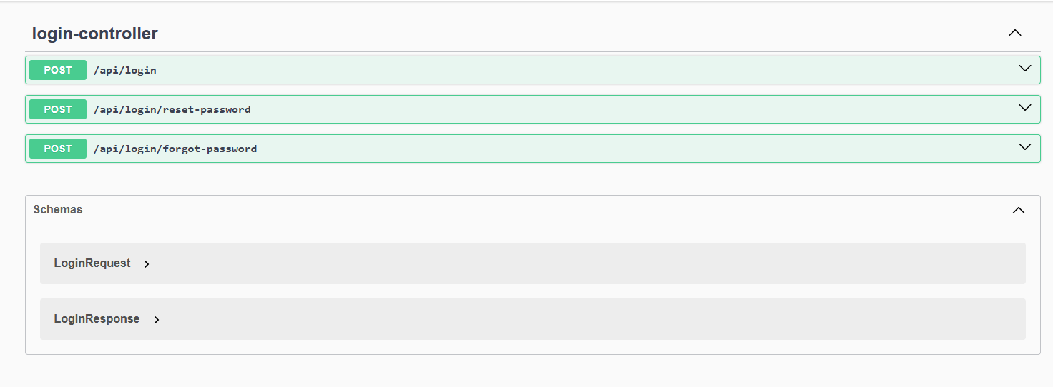

Customer Controller:

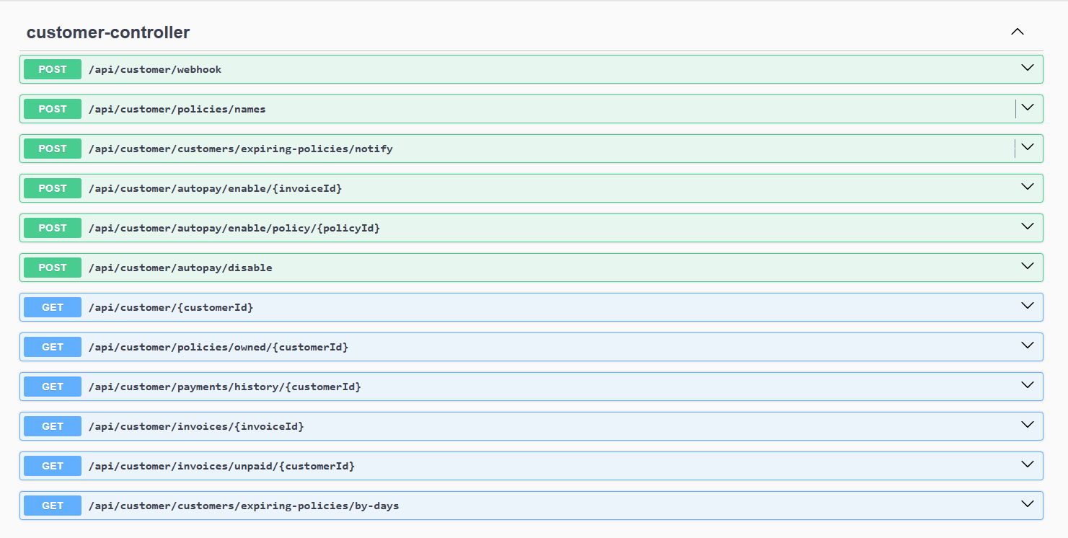

Insurer Controller:

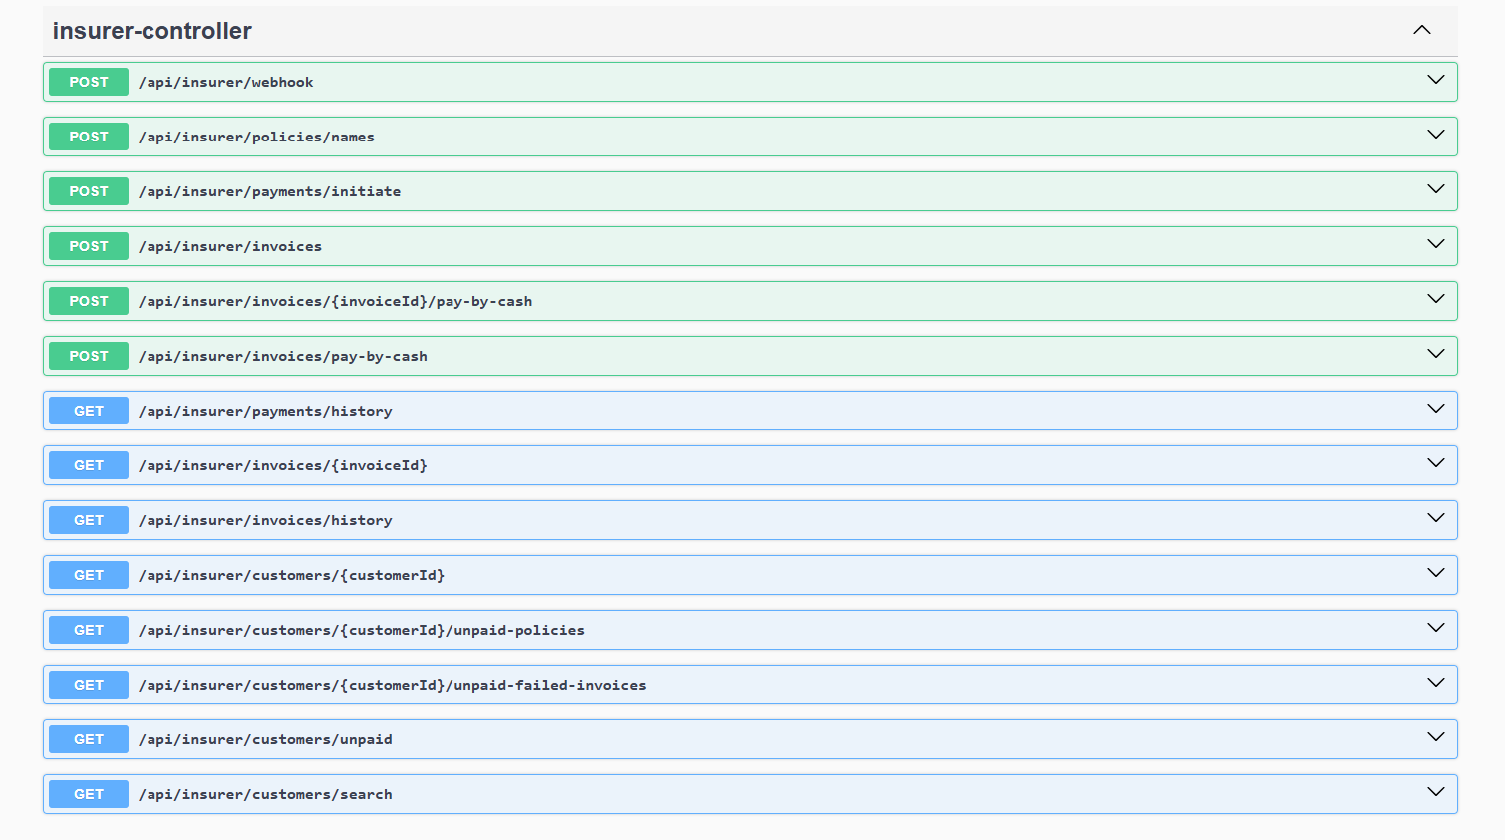

NOTIFICATION MICROSERVICE:

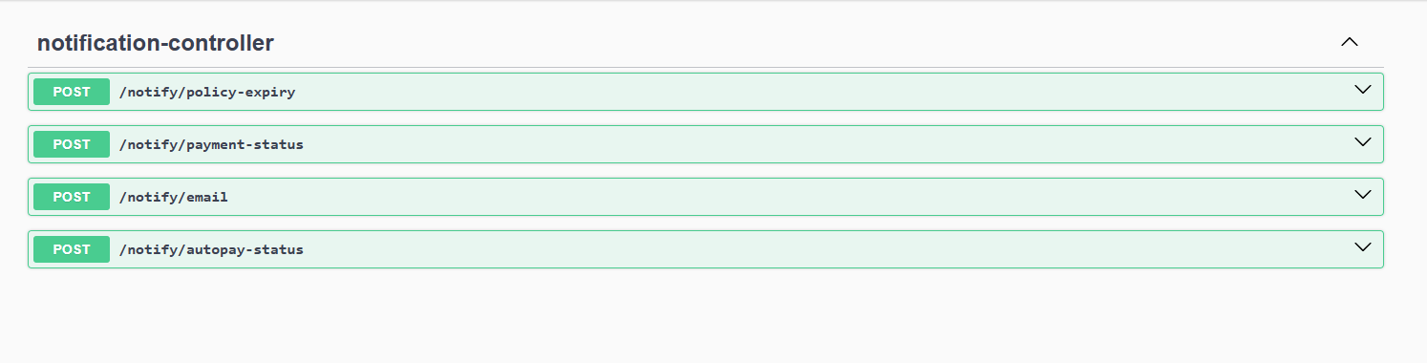

------------------------------------------------

POSTMAN Testing :

